## Merchant Name: Coram AI Implementation POC: Royce *(IM to fill)* CX POC: *[IMP to Add]*

### 

| Notes Sections   *(AE to fill if they have, Implementation to be completion DRI on handoff)*   * Info on how merchant bills   Upfront invoice for 5-10 year contracts. Harrdware/software model but not usage - quantities are defined in the contract  **Long-Term Contracts (5–10 Years). Majority of contracts are billed upfront** for the full term value.  **Based on Camera Feeds (Software)**   * Pricing is tied to the **number of active camera feeds**, which are defined at contract start.   **Hardware Sales (Cameras, Devices)**   * Hardware is billed separately based on the **type and quantity of devices** purchased.   1) What is the merchant temperament?  Alex is a Tabs friendly who’s buying for the second time with Coram. Former Head of Finance at Saltmine - also works as an accounting advisor for us. Invested in our success. Very smart and technical - will actively be looking to push the product limits  3) What are the Tabs features that the key POC cares about?   1. **Automate Invoicing & Standardize Billing Operations**     * Transition ownership of invoicing from Sales/Sales Ops to Finance, replacing the current ad hoc, HubSpot-driven process. 2. **Enable Fast, Scalable Invoice Generation via QuickBooks**     * Go live on QBO quickly (within 3–4 weeks) to streamline invoice creation and collections. 3. **Integrate HubSpot for Contract Ingestion & Syncing**     * Connect HubSpot for a seamless quote-to-invoice workflow, enabling Tabs to pull structured deal data automatically. 4. **Backfill and Clean Up Revenue Recognition**     * Reconstruct revenue schedules from **January 2024 onward** to prepare for a potential audit and ensure ASC 606 compliance. 5. **Lay Foundation for Advanced RevRec (SSP, Co-Terming)**     * While not immediately urgent, Coram plans to implement **SSP allocation**, hardware/software revenue separation, and support complex contract modifications (e.g., co-terms, blended terms) as Tabs rolls out those features - timeline where they will implement these features is early next year |
| --- |

### Billing model *(Entire Section: Implementation to fill section)*

* Are there unique things about the customer creation process for this merchant?
* Information on how merchant bills
* How contract is broken up
* One off things to know about the merchant

### Contract Processing Steps *(Entire Section: Implementation/Success to fill Post-Go Live)*

**General**

* Process all docs that come through, **including** those marked as ‘internal use’
* Ignore tax, do not process at BT
* Make sure to get the billing terms address from the contract
  + if there is a shipping address on the contract, use that as shipping. if not, then use billing address. If there is an account payable name/email stated on contact, use that as billing contact name. Otherwise, keep the HubSpot one that got pulled in from Tabs
* Check for auto renewals:
  + Only software fees will renew
  + Example below: 12 months of service starting after the initial term

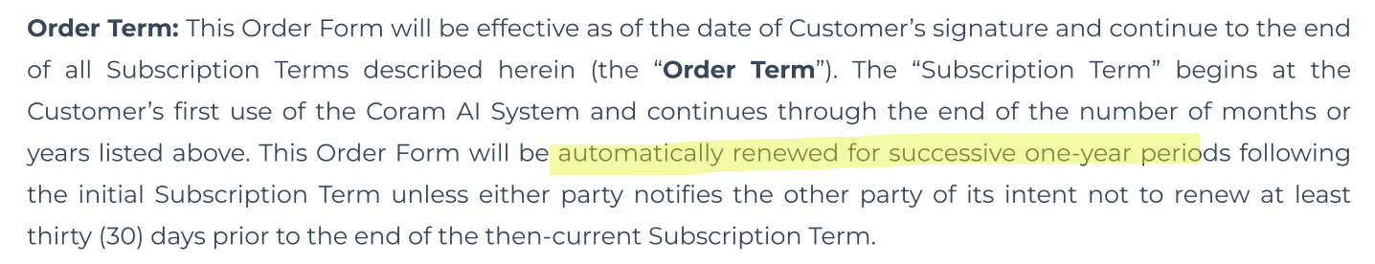

* Contracts will have hardware and software products - billing logic is different for each
* SKUs of Hardware products will be noted in the summary
* Software products always have “License” in the name
* If there is no summary, just go by logic that any product that has “license” in the item name, it will be a software product



Hardware Products

* **Service start date:** date of the contract (last signature date)
* **Total months of service:** 0
* **Item Name:** use the name listed in the “Item & Description” column
* **Item Description:** use the value listed in the “Quantity” column
* **Billing Type:** flat type
* **Total price:** use the gross price - you probably have to back into it using the value in the “Total” column if it’s shown net of discount
  + E.g. it says $2,805 after 50% discount, you would use $2,805*2
  + Add discount in-line, use the percentage discount noted
* **Quantity:** use the value listed in the “Quantity” column
* **Billing start date:** same as service start date
* **Periods:** 0
* **Frequency:** None
* **Billing Timing:** bill first of period
* **Integration Item:**
* **Net terms:** default to 0 unless otherwise specified

Software Products:

* **Service start date:** date of Licensing Term start
* **Total months of service:** use months in total number of years the subscription is valid for
  + E.g. 60 months because the below says 5 years
* **Item Name:** use the name listed in the “Item & Description” column
* **Item Description:** use the value listed in the “Quantity” column
* **Billing Type:** flat type
* **Total price:** use the gross price divided by the payment cadence - you probably have to back into it using the value in the “Total” column if it’s shown net of discount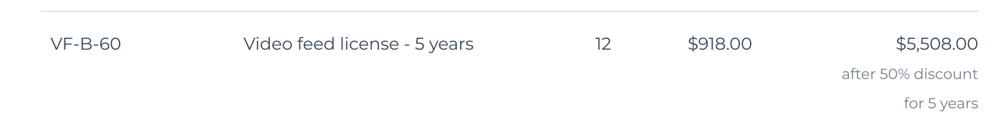
  + E.g. it says $5,508 after 50% discount, you would use $5,508*2 *divided* by 4 because the it says that the “Software/Licensing” will be paid Quarterly
    - See blue square in the 1st screenshot
  + Add discount in-line, use the percentage discount noted
* **Quantity:** use the value listed in the “Quantity” column
* **Billing start date:** use first payment date noted in the billing cadence section
* **Periods:** see billing cadence - if quarterly, use 4; annual, 1, etc.
* **Frequency:** based on billing cadence logic - quarterly billing means every 3 months; annual means 12 months or 1 year
* **Billing Timing:** bill first of period
* **Integration Item:** [Integration Mapping](https://docs.google.com/spreadsheets/d/1zoPddwYXAh7ZnpzR9AWWfYpDHekYbCulD-ue7uD9Qjc/edit?gid=555827318#gid=555827318)
  + Lookup the product name and select the corresponding QBO Integration Item

**Example Contracts:**

* C5f57475-0d83-4f3d-8523-c0a8627878da
* 705af407-3f06-4833-ba38-9357a829e1d5
* E2022f1a-dc74-414e-8b2c-7f305ade13ab
* e2022f1a-dc74-414e-8b2c-7f305ade13ab

1. Anything to ignore in contracts?
2. How do we handle taxes as a line item?
   1. If None Listed, Ops Default is every tax line item becomes a BT

### Events Processing (if necessary) *(Entire Section: Implementation/Success to fill Post-Go Live)*

* Any important information on events billing

Integration Items Processing (if necessary)  
*(Entire Section: Implementation/Success to fill Post-Go Live)*

* What are the instructions for assigning integration items?
* Example: All Statsig integrations items should be labeled as “Sales”
* Example: All “Pinata” integration items should be labeled as “Software Subscription Bundle” unless otherwise noted by Merchant

Post Processing Communications (if necessary)  
*(Entire Section: Implementation/Success to fill Post-Go Live)*

* Does the Ops Team need to notify anyone on the team re: completion of processing batches in Implementation or Active phase?
* Who needs to be notified and when?
  + Example:
    - Who: Customer Success [Azmat Aziz] needs to be notified
    - Where: Messari internal merchant channel
    - When: contracts are processed [Merchant Phase: Active]

### Customer Information *(Entire Section: Implementation/Success to fill Post-Go Live)*

* Any important information on specifics customers of this merchant
  + Special memo’s certain invoices require
  + Invoice changes due to merchant/customer relationship

### Feature Requests *(AE to fill for all requests prior to Imp handoff, Imp to fill prior to go-live/Success to fill to fill Post-Go Live)*

* SSP
  + Allocation of revenue for hardware bundles, free trials
  + Hardware/Software model where Alex is implementing SSP as new hire
  + Medium to High - aiming to use Tabs for this in Jan ‘26

### Merchant Calls *(AE to fill for all videos prior to Imp involvement, Imp to fill prior to go-live/Success to fill to fill Post-Go Live)*

* Disco/Demo/Negotiation (7/21)
  + https://us-56595.app.gong.io/call?id=7558709749661583153
* .
* .